Decoding of GNSS signals using usual antenna/receiver

Sergei Yudanov, Javad JNSS.
The Triumph Palace, Moscow, 125057 Russia; s.yudanov@javad.com

Introduction
Decoding of unknown GNSS pseudo-random code can be rather easily done using steerable dish [1]. Signal-to-noise ratio inside one bit is enough to get it's sign. This article describes method of getting these data using usual GNSS mass-market antenna and receiver with modified firmware. In spite of the fact, that only pilot signal decoding seems to be possible at the first glance, it is shown that in practice data signals can be decoded too.

The idea

The idea is to do coherent accumulation of each bit of unknown signal during rather big time. Time may be as great at full satellite path (for middle-earth orbits up to 6 hours). One of receiver's channels is configured like it tracks the signal; I and Q accumulated during one chip length in DSP, and these numbers are added to array cell, referenced by chip number, by processor. Only few info should be known about the signal: it is it's frequency; expected chip rate; expected total code length and modulation method.
BPSK signals decoding (as most often used) is subject of this article; looks like decoding of more complicated signals is possible too, but this should be proved. Limitation of method (as well as "dish" method) is total code length: for lengths more than 1 second and bit-rates more than 10000 KBps receiver's resources may be not enough.

Reconstructing of signal's phase

Method's "must" is coherency. During all accumulation period phase difference between real signal phase and phase, generated by receiver's channel, should be much less than one period of carrier frequency. Depending on GNSS's available signals, different approaches may be used. The simplest case is reconstruction of 3rd signal while 2 other signals (on different frequencies) are known and can be tracked.
The main (and looks like the only significant) disturbing factor is ionosphere. Ionosphere delay ( saying more correctly, changing of ionosphere delay) is calculated using these 2 tracked signals, then 3rd signal phase is calculated, as it should be in presence of ionosphere.
The final formula (calculations are trivial and can be found in variety of literature, e.g. [2]) is:

thisPhase = caPhase*caFrq/thisFrq*(1-(caFrq*caFrq-thisFrq*thisFrq)/(caFrq*caFrq-secFrq*secFrq)) +
secPhase*secFrq/thisFrq*(caFrq*caFrq-thisFrq*thisFrq)/(caFrq*caFrq-secFrq*secFrq) (1)

where:

caPhase, caFrq, - phase and frequency of first ("ca") signal, [cycles], [Hz]
secPhase, secFrq, - phase and frequency of second ("sec") signal, [cycles], [Hz]
thisPhase, thisFrq, - phase and frequency of 3rd unknown signal, [cycles], [Hz]

It was checked, that for all path period (elevations less than 10 degrees were not tested), difference between calculated phase and real phase was always less than 1/10 of cycle. GPS prn #1 and #25, Glonass-M satellite were used to prove this: C/A L1 and L5 signals were used as 1st and 2nd, L2C as "unknown".
If there are no 2 known signals and ionosphere delay can not be precisely calculated, theoretically it is possible to get it from the neighbor satellite(s) with 2 signals available. Calculations and estimations should be done to investigate the expected precision.

Experiment

Galileo E6-B/C signal was selected for the experiment, as it's structure was not published. From the open sourses [3],[5] it is known, that it's frequency is 1278.75 MHz, bit's length is 5115 bits/millisecond; primary code length is 1 msec; E6-B's data rate is 1000 bits/sec; total pilot code length is 100 msec (secondary code 100 bits length is present).
Javad's TRE-G3T-E OEM receiver was used. It is modification of TRE-G3T receiver, but with E6 band and without Glonass L2 band. Receiver was connected to usual Javad's antenna, placed on the roof and was configured as described above:
E1 signal was used as "ca", E5A as "sec". E6 code (consisting of 5115 zeroes) was 100% guided from E1 code (changing of code delay in ionosphere was ignored); E6 phase was guided from E1 and E5A using (1). 2 arrays for 511500 "I" and "Q" samples were organized in firmware; integration period was set to 1 chip (200 nanoseconds).
Galileo prn #11 was used initially, experiment was started when satellite's elevation was about 60 degrees and lasted for about 30 minutes only. Then data were downloaded to PC and analyzed.

Decoding of pilot signal (E6-C)

Decoding of the pilot signal is made in the assumption, that possible influence of data signal is small because number of ones and zeroes of E6-B in each of 511500 bits of 100 msec integration interval is about the same. First, secondary code was got. Figure 1 shows correlation of first 5115 bits with 5115 bits shifted by [0-511500[ chips. Because the initial phase of E6 is unknown, 2 hypothesis were checked: I+Q and I-Q, and for analysis combination with higher correlation value was selected.

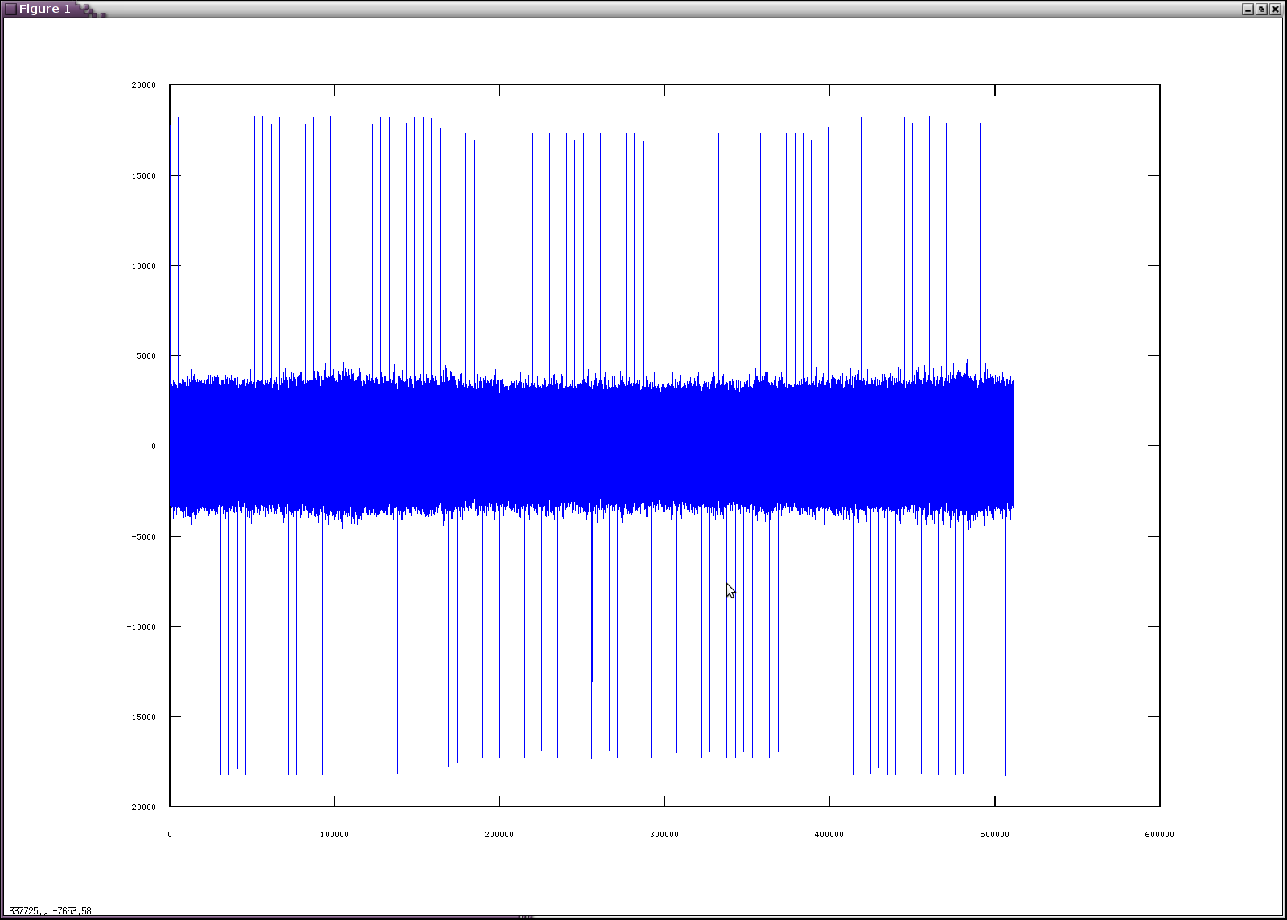
figure 1

From figure 1 secondary code is highly visible: after 5115 chips there is positive or negative peak. After obtaining secondary code, it is possible to coherently add all 100 milliseconds with secondary code sign to increase the energy in each bit in 100 times. Proceed, we have 5115 bits of pilot signal.
To understand the correctness of the procedure and check, is it enough energy in each bit, histogram of pilot signal is plotted (figure 2). We see, that there is nothing in the middle. It means, that all 5115 bits are correct and there is no any chance that even 1 bit is wrong.
But there is one effect, seems strange at the first glance: instead of 2 peaks we have 4 (2 near each other). In next chapter it will be shown, that it is influence of data signal and it may be decoded also.
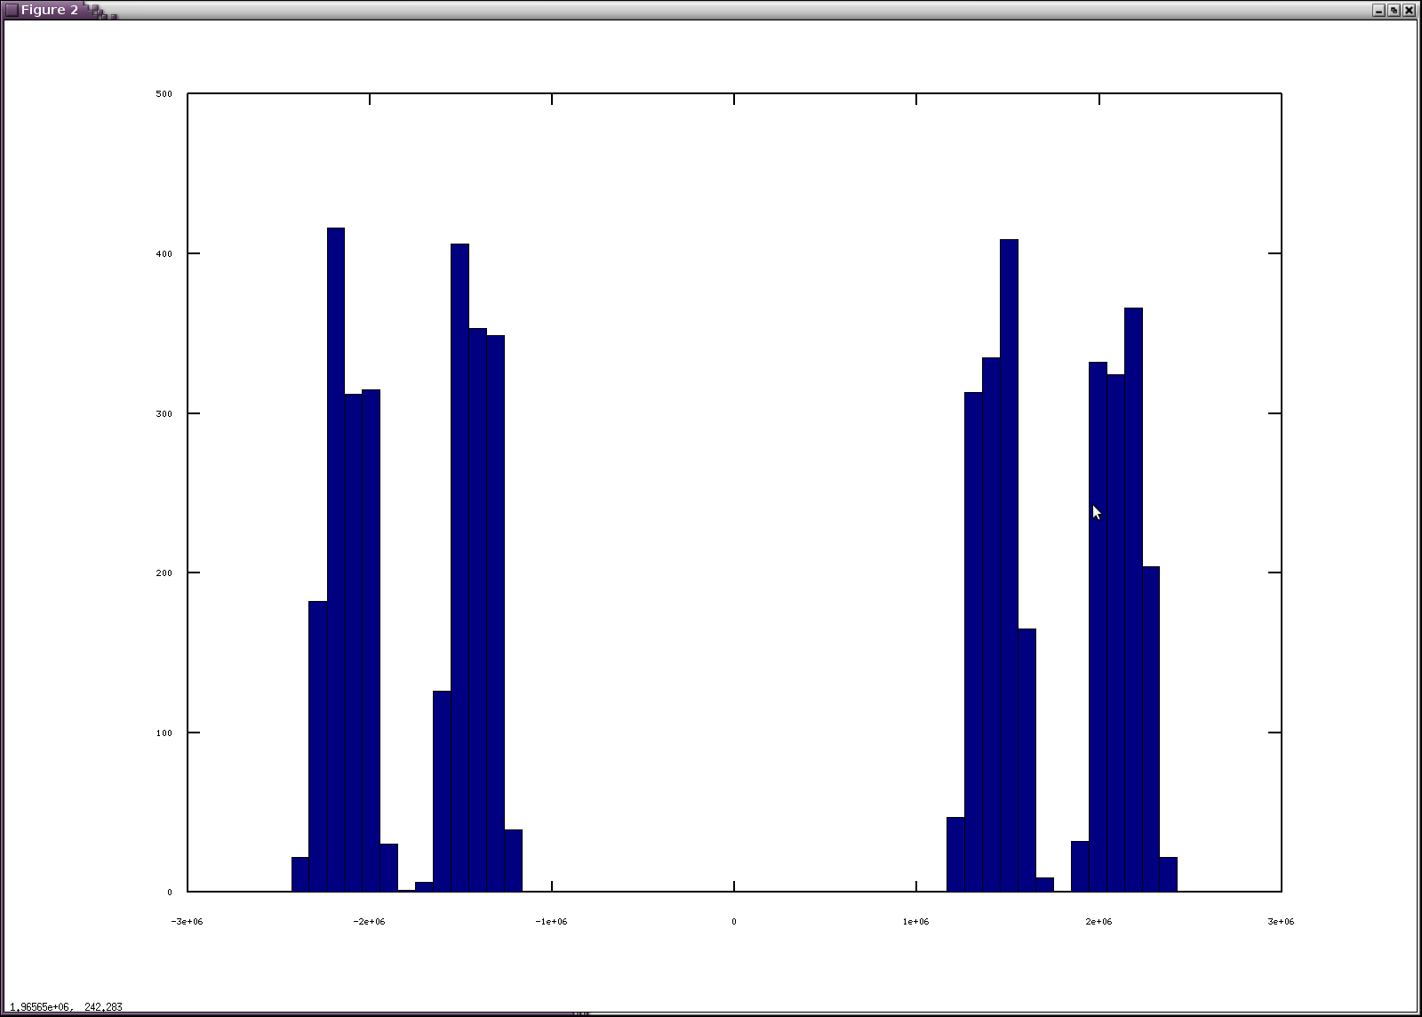
figure 2

Decoding of data signal (E6-B)

Having of 4 peaks on histogram was not explainable at the beginning, therefore plot of all 511500 chips was made (figure 3).

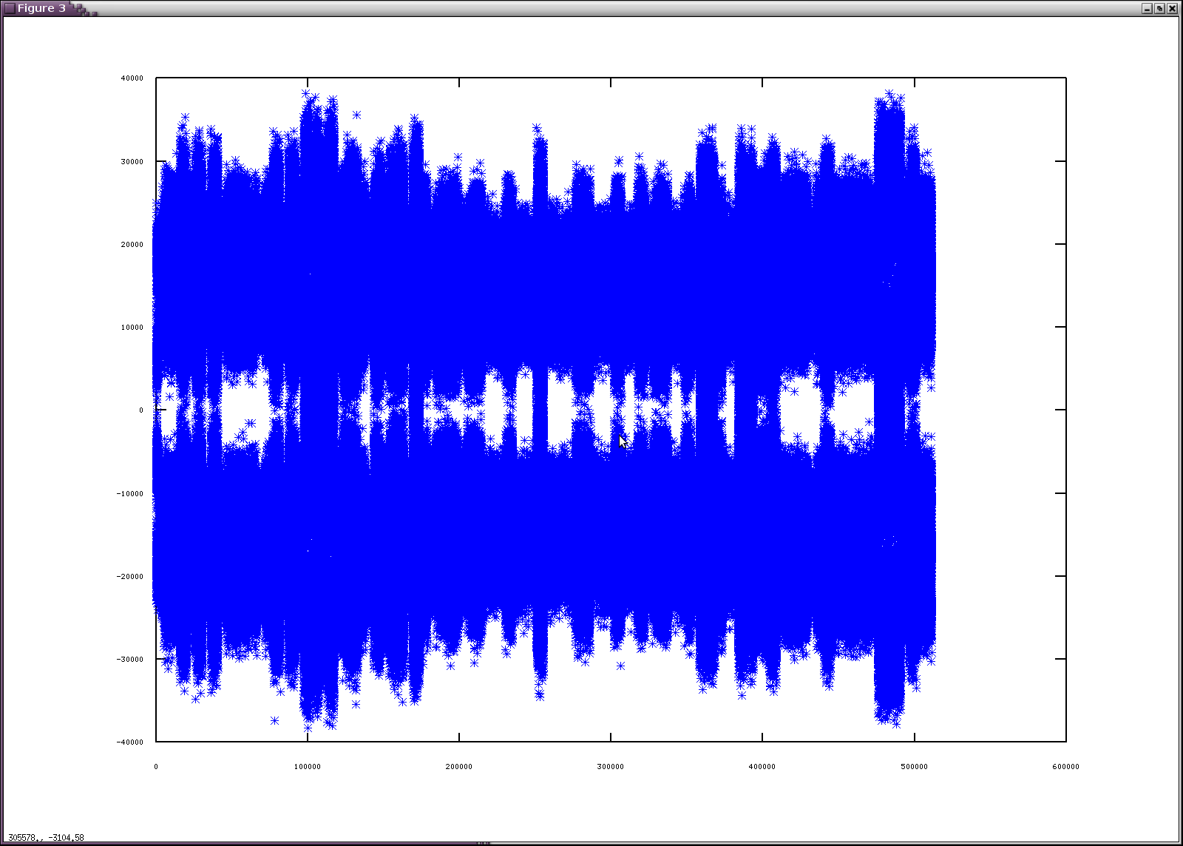
figure 3
Interesting, that each millisecond has it's own distribution, and such milliseconds can be found, where distribution is close to case, when 2 signals with the same chip rate are present. In this case there should be 3 peaks: -2E, 0, +2E, where E is energy of one signal (assuming B and C signals has the same strength).
One of such time intervals (starting from millisecond #92 and ended at millisecond #97) is shown on fugure 4. Muddle of the plot (milliseconds #93-#96) shows about the described behavior.

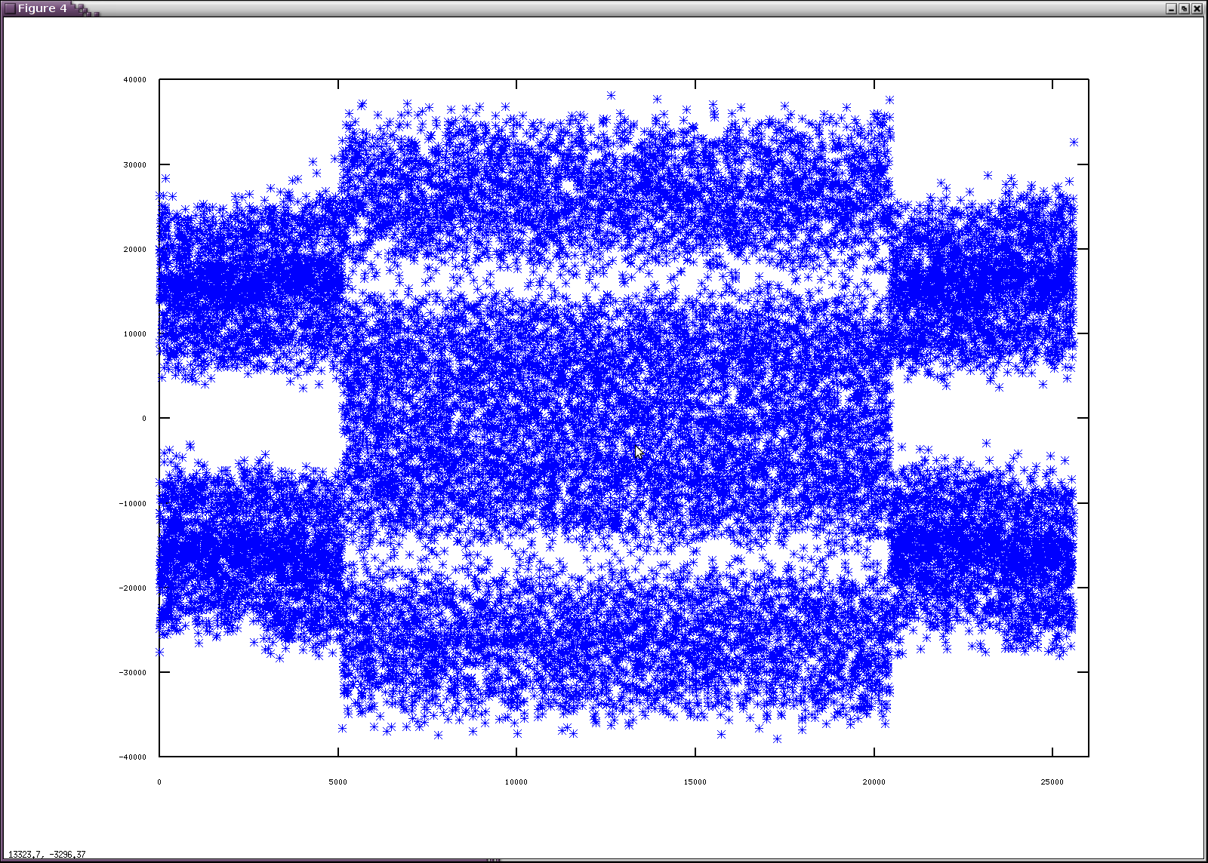
figure 4

Figure 5 is histogram of #93-#96 milliseconds.
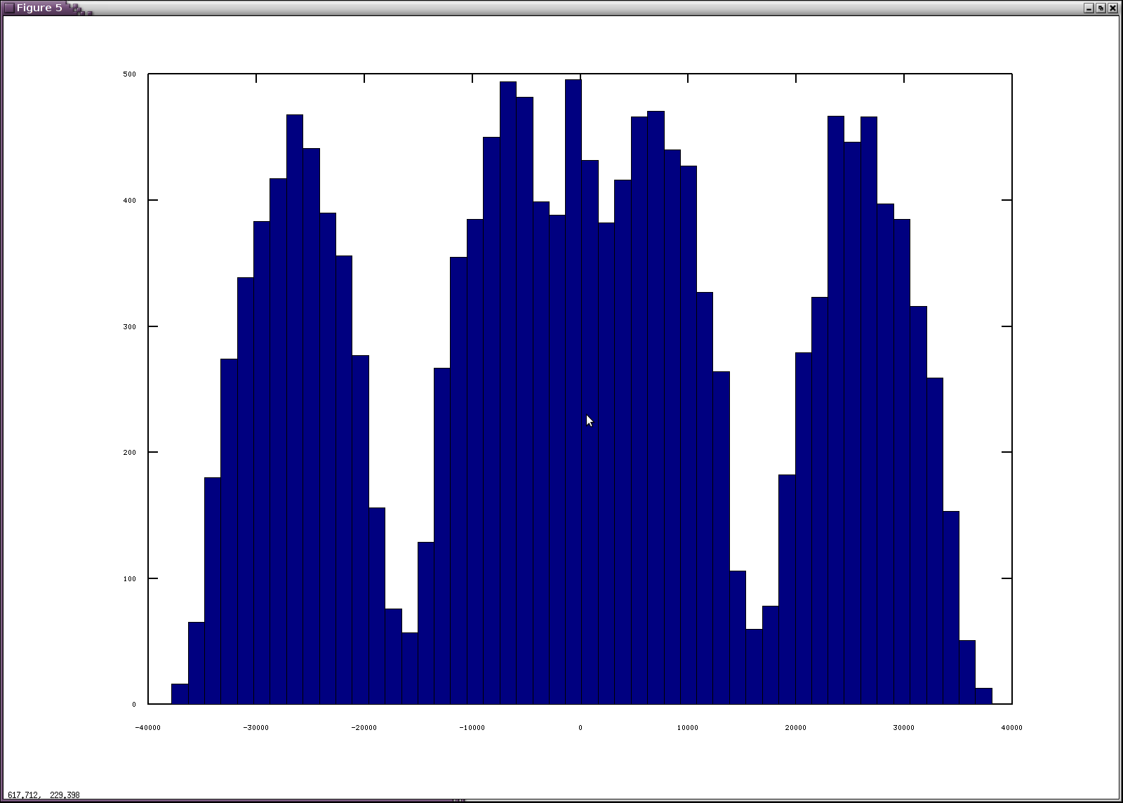
figure 5

Subtracting already known pilot signal chips from any of these milliseconds, we get 5115 chips of data signal. This method works when there is at least one sample (millisecond), where number of the same data bit in data signal is significantly more than a half.
It appears that for E6-B in almost all experiments such case can be found. If not, accumulation of only preamble bits can be performed easily.

Proving the codes

Obtained pilot and data codes were put in firmware, and receiver was able to track E6-B and E6-C signal. It is appears, that E6-B data has the same preamble as written in Giove ICD [4], and probably other data structure is about the same, but decoding was not performed yet.
Pictures with E6 signal tracking (phase, range, Doppler) can be found on Javad GNSS website
http://www.javad.com/jgnss/index.html
in “news” section. Codes for all available Galileo satellites (prn #11,#12,#19,#20) were got and checked.

Thanks
Special thanks to Javad's DSP system developers. System is flexible so it allows to do tricks like setting integration period to 1 chip, and powerful enough to be able to do required job on 200 nanoseconds cycle.

References

[1] Compass-M1 Broadcast Codes and Their Application to Acquisition and Tracking
Grace Xingxin Gao, Alan Chen, Sherman Lo, David De Lorenzo, Todd Walter and Per Enge
Stanford University
http://waas.stanford.edu/~wwu/papers/gps/PDF/GaoIONNTM08.pdf

[2] Principles and Practice of GPS Surveying.
The University of New South Wales. Sydnew. Australia.
http://www.gmat.unsw.edu.au/snap/gps/gps_survey/chap6/642.htm

[3] The MBOC Modulation. A Final Touch for the Galileo Frequency and Signal Plan
http://www.insidegnss.com/auto/1007-AvilaRodriguez-final-hires2.pdf

[4] GIOVE-A+B Public Navigation SIS ICD

[5] Galileo OS SIS ICD
http://ec.europa.eu/enterprise/policies/satnav/galileo/open-service/index_en.htm

TODO

- try to fix 1/2 cycle ambiguity (there are few ideas how to do it).
- try to decode E6-B nav data (using [4]).
- write more detailed article (more graphs, explanations, etc).

Appendix: codes.

1/2 cycle ambiguity is not solved jet, so there sign may differ from ICD.

E6-C secondary codes:

/* 11 */ {0xe03cd,0xbef9a,0xd5d3b,0x6427b,0xa1a98},
/* 12 */ {0xfe0a9,0xa7afd,0xac44e,0x42cb9,0x5d261},
/* 19 */ {0x99d5a,0x70162,0xc920a,0x4bb9d,0xe1ca8},
/* 20 */ {0x81d71,0xbd6e0,0x69a7a,0xccbed,0xc66ca},

E6-C primary codes

/* 11 */ {0x0b3b46b8,0x8d317b96,0xacda34c5,0x1109f42a,0x9beb8521,0x17fabe39,0x01a0a9ac,0x200ae55f,
0xa89b2905,0x384a64f0,0xc9a10505,0xb305ea15,0x1653a826,0xcd0648c1,0x46fcd709,0xe836a775,
0x730436d7,0xfa5fda10,0x7816d34f,0x95e22502,0xdbf68c6a,0x3b2bae76,0x2dd6486c,0x5dbe37f1,
0xbedb0676,0xf1fe79b8,0x411056ac,0xb4aee724,0x1509abcd,0x2992d5f5,0x68aa0a11,0x21a82866,
0xcf4aeed0,0xb7dc9cd0,0xc8a564f7,0xa5016c72,0x79dec611,0xcfcb208e,0x95547b26,0x5dcc07da,
0x9ebd92cc,0x40cc28f3,0xce7eb884,0xdb45e3c1,0x8f9dd7e8,0xbeb3a742,0xf63f3011,0x7dbb9880,
0xd4c0a0ed,0x422a35cc,0xff3030dc,0x07ab01f7,0x45ebf3dd,0x1e8dff2e,0x83b3c973,0x73325ff4,
0xeb4d7606,0xe08a082b,0xb2c0aa93,0xd9173ab8,0x9cbf208e,0x4fe566cf,0xc7249752,0xa76545a6,
0xc310877a,0xd4a9851f,0xb84e889c,0x79dff687,0x1ba04918,0xc7f53319,0xa8a5ed12,0x3fd590bf,
0x8f4a8f4b,0xf32fa1c5,0xe96b6597,0xe88e5cb6,0x19949374,0x51c93db3,0xbdfc99d1,0xe3e3f3b8,
0xbb7ff2b1,0xf5bca935,0x8622f787,0xc62ca4c4,0xe97b4e03,0x98b7ad97,0xab352811,0x1ae82ab4,
0xb297d396,0xae38b534,0x671719c5,0x34ea98a7,0xa121a2fa,0x95e3c8a4,0x37d45b26,0x1c2e88cc,
0xd95ab9e8,0x4f86f1e3,0x9783ea40,0x331eb371,0x857b98f3,0xfe01f283,0x3820159f,0xb59bb13a,
0xad28d50c,0x44c02c0b,0x302b56bd,0xca1ecde9,0xa2eb4e0b,0xedcce00b,0x8290851a,0x4d5bd6dc,
0x84f263df,0x7a10383f,0x141c4866,0x2879de27,0x25b33859,0x86992312,0x2c8527b0,0x61bb588a,
0x5e0e309e,0xff883566,0xc1ecee85,0xd4f79759,0x881b1988,0x0ab79a72,0x655a3016,0xedde3339,
0xdc4f709a,0x0f38cfe5,0xf7881682,0x3c596d72,0x74719618,0xfd8fc128,0x589f2297,0x51e7b450,
0xb160af50,0x3c7ec71a,0xd041a4a8,0x4024a9dc,0xf3b0b2eb,0x020956ac,0xac1d95ec,0x99005f4b,
0xe55c8fc8,0x8f2b928c,0x4c14d89f,0xc3ca1c93,0xff7b683c,0x34fe27c6,0x71a7dcc8,0xf2e70bf4,
0xc453cd52,0x12f97e6e,0xca5742f9,0x8aa69c43,0x886c191f,0x51f50649,0xf046b71a,0x077e67e9<<5},

/* 12 */ {0x2e8b39e8,0xaa97ca4e,0x62a69f1d,0xcaab338d,0x248b2f15,0xe0502073,0xfdb93051,0x95700117,
0x9d3465ad,0x7e1470eb,0xff972679,0x2ecc54ea,0xf2bfcd91,0xd057844c,0xbaf251f7,0xfb5b39d3,
0x6b6d0a06,0x9aac262b,0xc5e051e8,0xfeeb163b,0xbacfd162,0xde304f3e,0x65615f7a,0xc5863b6c,
0x864bfd9a,0x5bb1f7e8,0xded30adb,0x6fe95d83,0xb3d33181,0x45e35602,0x9770b938,0xad61268f,
0x9bdf5c13,0x32e4afa8,0x9f9414fb,0x8f5c389c,0x87942888,0xe3184602,0x4a3783b4,0x5d85c581,
0xe9afc910,0x480f96a3,0x1bc9aa6e,0xdf91d811,0x78bd7dfb,0xc2aec56d,0xf46bc75e,0x0fa23eb2,
0x06c3a2b6,0x2f832bb7,0x8c7f833a,0x828ac7d5,0xd3a1941e,0x6c8bc4ce,0x82a4b6e4,0x667b13de,
0xa151846b,0xd904b09b,0x2e39477f,0x9ca14af9,0x8b863655,0xcae17293,0x436759a5,0xeddc711c,
0xb8e8c403,0x3b819271,0x28ac0b19,0x6bd2309f,0x5f5b3ea3,0xde25e85e,0xc00ff5af,0x1e8a086c,
0xa14eec5f,0x771b1079,0x178058ef,0x256c4661,0x665302fe,0x0104970b,0xeab507a3,0x2083992d,
0xfcaa0613,0x2ae69630,0x2cc5431a,0x73e4e7f8,0x1fbded3b,0x2fdf6128,0x9510bfee,0x9079e44a,
0xa7a7a1eb,0xb36caeba,0xe3519fa2,0xf489a378,0x4a52ae58,0x5bcf5f47,0x2a2fa1a7,0x689ec82a,
0xefd3088e,0xabb5099d,0xfe4dac2b,0x99a0e009,0x6188a5e7,0x2b5480db,0x5fff5c1d,0xc8a96b4f,
0xc306cc01,0x3508fe6b,0x6454994a,0xe9f9a961,0x33d13b0d,0xb2d8df1a,0x1e214973,0xc8a6b5ed,
0xa911c891,0x5316d5a4,0x8d7465f2,0xe10afacf,0x0218926b,0x230f07c2,0xc6c1cce7,0x0101ee1f,
0xcadc4440,0x2030ba9f,0x1bc4a7ce,0xc622e8d9,0x6178150a,0x853571df,0xd3ae02c6,0x25af19f6,
0xa23f08cc,0xcd312d8f,0x233f60e5,0x92e9ec03,0x145716b5,0x125ea3c9,0x3e3b119b,0x8c399770,
0x03254b90,0xe1d9a80c,0xef7bad77,0xdecc6711,0x0da38d19,0x04e8165c,0x8ab8e469,0x2aec81ed,
0xb92fca49,0x97ec8e41,0xf7055312,0x9cbbb161,0xc94300b7,0x59625680,0x352e60b5,0xa8a37370,
0x3803b533,0x5ee20f6b,0x86447b77,0x336e461e,0x4f3e2ba7,0x594cf37c,0x967dc8fc,0x01ef8eb1<<5},

/* 19 */ {0xcc8ae040,0xa281117c,0x472f7c87,0xe108b575,0x563e252a,0x5c96064f,0x9242f3d7,0xf2544fe0,
0x6dbaa94f,0x6847bfb8,0x9b3b6aa1,0xc57f5a4e,0x59feda18,0xe365a24f,0x4d1e3a87,0x76768742,
0xbca81bf7,0xfa596a7b,0xe09cb190,0xcf9fc5d9,0x37fba0cb,0xb6721b3a,0x8b6860ac,0x3eb8b39a,
0x19365dea,0x72d22db1,0x46563106,0x544dd6e4,0xeb47c7dc,0x740f2ab1,0xc5e44660,0xd41abb46,
0x7237fdaa,0x712bb7eb,0xdef27716,0x1178483a,0x3e1d73c6,0x8e421130,0x70e92f36,0xc82be020,
0x48b61735,0xca16ac30,0x2a0821be,0xb0eb4a4c,0x84e425c6,0x1a549556,0x744942cb,0x0f6055ec,
0xcd3d4d56,0xb1610ba7,0xc6621c75,0xac449ac0,0x2de04a27,0x70e792b6,0x5d004aa9,0xcd8dfa96,
0xf12c5bda,0x8782fb08,0xec0e3ea9,0x57cfbfff,0x321d7c57,0xf8dd78e4,0xd561279a,0xc33e522e,
0x33f517fe,0xb5bb78ec,0xc3bdc325,0xe8c5fd75,0xbb4a7362,0xd9d995ad,0x4b86d3de,0x969d06a0,
0x4fd9c99f,0x3dc4da88,0xba4f99d1,0xc37c2e96,0xa302cadc,0x30a7de63,0xfc1f7585,0x3d2e8b15,
0xe2396cd6,0x617ea771,0x29d4d63e,0xa1d103db,0x0604b015,0x3f234b48,0xec4f74e3,0x12d1582c,
0xd88cf6cc,0xb9587301,0x06667a49,0x0da0530b,0xb66d909f,0xd1dfc725,0xd104ecd8,0xfe1e8c3f,
0x0ecd9553,0xe3553af1,0x597cc690,0xbfd9e836,0x90ee7deb,0x4edb6069,0x61a1e537,0x16075564,
0x251a6895,0x49ab1cf2,0x6c14375a,0xfc82510f,0x8e5ec467,0xefda137d,0x77a3640c,0x87099eee,
0x6052c893,0x56c1a7f3,0xaa2274f6,0xa7e6485c,0x5ef1e91e,0xff12202d,0xf45c6f3c,0xe0e7c042,
0x4c141fc9,0x46b451a4,0x72a9139a,0xe0e9ea50,0x0ff86f3c,0xbc9eb021,0x706038e7,0x08a32ccb,
0x11412b42,0x10457379,0x58216135,0xd63b7364,0x181f4cad,0x70b7c15d,0x4d0dd8db,0x5bf2e20a,
0x5f103855,0xa7ab306f,0x26055c65,0x8308036a,0x72637696,0x987e5d84,0xb8664cf5,0x52fe3cdf,
0xb8642101,0x5170ce7f,0x802da7cc,0xf8921096,0x536c3da9,0x237ecae4,0x3a16a736,0xde01c595,
0x259aa18b,0x858ed081,0x183c726b,0x63fc2d13,0x72fedad7,0xf48c1950,0xfe1cfc15,0x02f30872<<5},

/* 20 */ {0x48413984,0x1f009789,0xd245bf4c,0xe2dca446,0xc9e56707,0x2d2ac703,0x10891ad7,0x91149883,
0x25503215,0xd970f249,0x7b61ebf5,0xb4f01350,0x2b2fd6d8,0x14f6abc8,0x3d393d4d,0x3f9a0333,
0xeb34a7f5,0x9b830ac3,0x220f605f,0x2171a24e,0x32fcf142,0xf311405d,0x018899b6,0xf2f39e59,
0x6f206551,0xb69ed971,0xae471a1c,0xa07c810f,0x7f449b4d,0xe20cfc64,0xc959debc,0xd7b7bf71,
0xc083f99b,0x9ccad3de,0x004772f9,0x5d078699,0x04ca49a5,0x726e40d6,0x18f4c028,0x70983f66,
0x74179dd1,0x2c3b7119,0xeed01b29,0x2e894bb7,0x2a2aa3ad,0x49f5e059,0xecb35458,0x91a0438b,
0x30b4317a,0x5e4921f6,0xe7664822,0x53994cac,0x21feaf85,0x94909618,0xa5dff8e1,0x6b02a80f,
0x3d92b710,0x8f0dc38c,0xa52e3de3,0x4edd8f61,0x864078a1,0xeaf32d96,0xba614a47,0x2cd7120a,
0x3cbd9ea6,0x9a521092,0x212d53a7,0xc4e087cb,0xdf86b615,0x5012c1e3,0xd35d41b9,0x0a8d2295,
0xcbbace46,0xf9cbd665,0xf66d639f,0xd5cfed13,0x4f8c72c9,0x46401c9d,0xa210d91e,0xe0c40e86,
0x5b522cdb,0x50e1579f,0x66c2b217,0x7e5b2cd4,0xdf6bcd22,0x282f7c51,0xb5c81c01,0xda04832a,
0x2b8bcfce,0xe2c846c2,0x80ce6e36,0xe523facb,0x198f0a78,0xee9c3f65,0x42328d3f,0x47447968,
0x39d11643,0x2ce96f99,0x56804125,0x16f6cd85,0xcabff05e,0xd076ea1a,0xb93e7cf7,0x67137eb2,
0xa433ba64,0xdb20b5f3,0xb1bf50bf,0xa7dbe246,0x7685c19d,0xebd16d5e,0x04e040bf,0x4dd531b5,
0xe0eb48ba,0xbeebbc4a,0x5f6d511f,0xac6c8b09,0x220d0007,0xb21cc289,0xd6a1091d,0x172219c6,
0xbca7de43,0x303de4c6,0x1fcb14fe,0xad3d4a3a,0x3c5070f8,0xc5b57caa,0x909b6d4f,0x8379acbe,
0x8a4121dd,0x0beb5b18,0x8fed5b95,0x8767dd5f,0x69db955f,0x777f1bc7,0xc600a2bd,0x8b87b00c,
0x19dbfd9e,0x5dfe3059,0x65bc7a6b,0xb3b1aec9,0xea41346b,0x78fc4579,0x1c9a8f3b,0xab66fbc5,
0xba8da94f,0x68cd9742,0x098b80a7,0xb08978fa,0x902837f9,0xf0d25f7b,0xbfa7d49c,0xda55e213,
0x886c7e5e,0xa82d983e,0x9c51237e,0xe6b2bea4,0xd4fbe14e,0xae28116a,0xd792c0ac,0x0023cf67<<5}

E6-B codes

/* 11 */ {0xf28c3e75,0x420656b8,0x6725900c,0xe0b35ca3,0x246a13d4,0x5516426e,0x9fbcbc74,0x51aa5257,
0x4e141770,0x63d74ac2,0xe20cc7c1,0xf4fb895d,0x5ad29118,0xdd3748e1,0x06a9c7d7,0xcb859a32,
0x887e80d8,0x42f92ce8,0xb3c4e285,0x52135884,0x8eedfc47,0x8872a421,0x50da6732,0x89494088,
0x55488bc9,0xcdfd3b50,0xa89da024,0x3e6c0153,0x21ac3750,0x63b36bc6,0x48c8cfa3,0xd1bc3e01,
0xbf50f6fd,0x3ba35d72,0x5e5b05a3,0x08c57729,0x6acb7571,0xdad97602,0x7bf602fe,0x4c3446df,
0xed2e82a0,0x86bd132f,0xf872e269,0xf6770f0f,0xa7e36acc,0x56f7da2e,0x8a504431,0x9c2b8ce0,
0x999510f1,0xc467eae4,0xba80e86e,0xfe289d92,0x9953e561,0xbbc052ca,0x5b8ad2f5,0xb8cfe166,
0x9466bfe2,0xff823a66,0xadcb0181,0x9fe7977a,0xc2f0dc7f,0x2262411e,0x3a790b53,0x18fef83a,
0x8bcf5929,0x063928c1,0xaede2887,0x7a6374c6,0x68a0a2e5,0x4dea5af1,0x730277ae,0x3ff4bac2,
0x40e0ca97,0xaf936232,0x8d45ae4b,0xd78866d3,0xa2756170,0xfe9df751,0xf4827684,0xa43030ed,
0x6e59587d,0x242463ca,0xbf5f9404,0xaa6565f3,0x05b6cee1,0xcf4c6f97,0x96028015,0x30e1760e,
0x39be3102,0x184c98e6,0x33eb4efc,0x86e479f6,0xd2bd6e16,0xedf573a7,0xcdcccdf0,0x05c993c5,
0xb35d6517,0xa5e703c5,0x7037656d,0x1ce0b668,0x35adda24,0x684fbc9d,0xa33002df,0x1ff7a46b,
0xe81cab3e,0xd4ee9c5c,0x9ee0c61c,0xdf473d50,0x0ab3f00c,0xb2b1bc37,0xdbec7550,0xe5d604a8,
0xa58bf877,0x0643fe8e,0x165268b0,0xf3b7cc01,0x5d2ca76b,0x3230d14d,0x48545f41,0x9b5aab0c,
0x9d0e230f,0xd44618d5,0xa49c5749,0xc7bed668,0xc7336806,0x758b629d,0x823f1689,0x4faf8316,
0x085a88db,0x6bf519af,0xf6e19412,0xa767ff1b,0x31acc3ce,0x1327e97b,0x47aae48e,0x368ee95e,
0x1d6ef341,0x968883cd,0x2e4885df,0xbebb7d1e,0x8fb51cd2,0x0e5a62b3,0x21f0110a,0xb1738f31,
0xce679711,0x4340ae65,0xcc0ede54,0x8d0220a2,0x81f4b2bd,0xb733def7,0xd792f401,0xe3393e2b,
0xad9c279a,0xcc051ac1,0xecd1819d,0xfdb55603,0xe6ad7146,0xa4d233df,0x28d3a4d8,0x02e0b6f2<<5},

/* 12 */ {0x7c1da14c,0xa0156b76,0x06b9f0ef,0x8b5bb8d8,0x8ee020a4,0x4e7f2c00,0x2c113a65,0xc496a927,
0x0d9d436b,0x8e2b7b86,0x028209ee,0x65f4c251,0x09bae973,0xb52b58f4,0x5295ce31,0xf5133277,
0xd13be1ad,0x354d142c,0x3c1edb45,0x92558fce,0x8d559432,0x497a2c9a,0x1bcc80f8,0xa6b4e677,
0x0982f4d4,0xb73dbb29,0x6ebea34a,0xf05d1b0c,0xd7fa32ed,0x2369ca76,0x6d4555cb,0x5550ee08,
0x830c4390,0x713f8631,0xfffd8dca,0x56ae7506,0x05e977f6,0xb06b5c97,0xa23a874a,0x3b0d6e47,
0x946eafed,0x0e91ca1b,0x34566be1,0x9311debb,0x418c98fc,0x5aa8fb66,0x71d497af,0x4b491bd9,
0x3ba6e77b,0x6a731121,0xac393a1d,0xe588c27d,0xc51d7ae3,0xe7be1d56,0xc02d5b71,0xae12d90f,
0xfc9b034f,0xa8fcb7de,0x60a4ad75,0xab94ff7a,0xf1fed1ee,0xb4c99c4f,0xf0a3dee2,0x0dd455e0,
0xd136db77,0x8b25a838,0xc09c6199,0x923776c0,0x0c9d0762,0x8895e99c,0xbdab9c05,0xdbe6a7c7,
0x6f2cbc78,0x05d4a615,0x480037c9,0xa1809355,0x839eb3d7,0xc1ac3219,0xf317a98d,0x49945446,
0xa1d48b12,0x61255724,0x00d126d7,0xa6f57cae,0x612c1990,0x4f9fe12f,0xdee2d637,0x1e77159c,
0x5626eb12,0x8767ed42,0x2c5ae083,0x683c1fe1,0x3e1b8291,0x39bdcc61,0x810d2be7,0xf0d1b4c2,
0x1edec02f,0xc080441d,0x3585fd67,0xe6a55017,0x3e18f2aa,0xb70ec125,0xd3378772,0x94e2ede0,
0xa8852e30,0xcea91783,0x628d0468,0x5922f40c,0x89f57d77,0xc38b440f,0xe27a92cd,0x691346c3,
0x9e73106c,0xfbef8bcf,0x5db48f20,0x0c39ca6d,0xcf165a62,0x5be029d2,0x585c4105,0x9bbc0d25,
0x44eedabf,0xda84c028,0x40456505,0xf4ce8cba,0xc03bbbc2,0xdce7a01b,0x5573662e,0xf6638ca0,
0x9a76c58a,0xcba41d76,0xf5822c64,0x06ff426f,0x39cb87b2,0xfae33153,0x73dc7c1f,0x99bf14e3,
0x28b50771,0x470446b6,0xb4714dff,0x275e6857,0x240cb4c2,0xe0b7dc12,0xf97bc00c,0x8f77c3a7,
0xbc30467c,0x72b306bf,0x61aa3760,0x6ae51d57,0xd8dc74d4,0x608d3ebe,0x49a63d42,0xe72c3510,
0xe57484c1,0x33d7cce5,0xf69718b6,0xd7718b06,0x1cd62824,0x849dba1b,0x9ff1151c,0x0067fad3<<5},

/* 19 */ {0x999334a5,0x4881fd1a,0x03d6c8fc,0xc0f974f2,0x7002db6e,0xd452fece,0x0585f7e6,0x7c29fa76,
0xedb91791,0x41cea6de,0x2c9e7210,0xb6f6926e,0x7225bfdd,0x2e1d7ff1,0x9800b4ba,0xbf8a8c97,
0x3d3531c3,0x0c741553,0x5915cc5c,0x82980cbb,0x956a1d79,0x65b38d2e,0x0e61a5dc,0x4b712565,
0x09f08bd2,0x471a3be3,0x63e30b9e,0x95d1cfd6,0xff87b1d6,0x7c5baf0e,0xc1d0b364,0xbcd0fc6b,
0xc3630ff0,0x30ec72dc,0x9586deef,0xdfa39986,0x6dd4acba,0x25b118ec,0x33d15979,0xb2d65315,
0xfa3e9b32,0x09681e99,0xd8d9a74e,0x60fbbc25,0x78441df8,0x96340332,0x5496ef39,0x19157378,
0x6976d246,0x1888459b,0xfa938c55,0x3c8af97d,0x124621dd,0x30851788,0x956c4330,0x18878429,
0x7dc079d7,0x48468aaa,0x119fa356,0x06a8ff96,0x1ae3d8dc,0x0a83cea6,0xf4c525a1,0x86719104,
0x2de02d38,0x1ea126c5,0xa427ad47,0x91335aa7,0x6aa903fa,0x4c5fa836,0x6a7aa07a,0xefe02336,
0x0a1af93e,0xc576853a,0x1e75c2f5,0xfc6eb395,0xc65de74b,0x746706aa,0xa558fb27,0x8b2641f3,
0xe2ebb912,0xb99458d2,0x0014f588,0xf070e80a,0x38f9a86a,0x6202c17d,0x7afbb32d,0xbae8cccb,
0xb6c7da1f,0x4abeaa76,0xed0bf1a9,0x182051a6,0x4dbe176d,0x49d48ed1,0x3c0ca3d2,0x3653fedb,
0x0f342458,0x617c4ca7,0xe1355aed,0x9b173f03,0xc503cb8a,0xa7a96e21,0x5c528444,0x357ec2ba,
0x885859a3,0x2dcbf2d6,0xa0945d70,0xe0c100ab,0x2f1457aa,0x0543757f,0x7fea800f,0xbff2fef6,
0x7b936ca8,0x1fc91e62,0x5d359934,0x43e04589,0x81d76b93,0xd658ef83,0xdc3aa01c,0xf068e3ae,
0x4309fd7a,0xce741c4b,0x3f1b3a04,0x743b6ead,0x6a3db9e7,0xa0a231da,0x26844f4e,0x1bc7a7c3,
0xd8d059ad,0x5184d896,0x25d00e92,0x79f90a5f,0x468ac7f7,0x6c0367d7,0x2af1a9b3,0x631a23c1,
0x6af44484,0x3b30612a,0x27920f0a,0xb07b6c74,0x4c86cf7a,0xbf281b2f,0xe35eacbd,0x1973d383,
0x4f06ce39,0x19e9a060,0x5634e6ce,0x3d2995cc,0x951d550c,0xcd38e1bf,0x1fbc02a7,0xd9116fdf,
0x6eec56a4,0xce44c89b,0x1ea46062,0x5596d2d1,0x3c542336,0x2dbe36e6,0xf8129e00,0x00c6b59c<<5},

/* 20 */ {0x81b17b29,0xe24d537a,0xc89f10fc,0x1ea01c8a,0x954a4295,0xafc1ff83,0x540b1721,0x56b06367,
0x5d4d67a2,0x4cc84993,0xb423f481,0xb38b227f,0x4f054a2c,0x0efc5198,0x98c2ef0c,0xc321711e,
0x5a870775,0x86dc5912,0x0268a143,0x4aea3f48,0x12157c08,0x77f69281,0x62bf9859,0xb3e42990,
0xeeac9ce8,0x1777379b,0x67fd36a2,0x6ee8645f,0x6bd00474,0xf49a4e03,0x7df6d15a,0xa5dba827,
0xe8e133d2,0xc9e562fb,0xa458ac5e,0x08976d88,0x5af96570,0x39b9b884,0x7ecb973b,0x57b9cd75,
0x6f290b8f,0x82aed64b,0xccf4361e,0xd525f766,0x507da9e8,0x74b8f80f,0xab5beeba,0x885603c0,
0x162656fb,0x691755f2,0x44bdc9d7,0x58e32310,0x1e9c6aa9,0xa51ecb64,0x30e64f81,0x85d93378,
0x3f1b324b,0x313a1587,0x4e70b3af,0x65593881,0x89c0fbc7,0x4efa9fcc,0xe23e72e1,0xe99dec39,
0x8200c716,0x937d4c4c,0xa98c6f0e,0x45081a5f,0xbe3731fe,0x5962315a,0xd0af432f,0x0c8d6e8f,
0xc6b3b01e,0x083ae1f4,0x0d2ad886,0xe15f2975,0x5cfc4ec2,0xb6e644fb,0x0448b2aa,0xf86bc059,
0x66a01ac1,0x91f1d47a,0x29da34a7,0x7e11cdc4,0x72e9bef5,0x0b4964e4,0xd4f37b8b,0x218549dd,
0x6ecc1fb6,0xede38b45,0xd2adbfe5,0x34b736aa,0x246a838f,0x86cc6851,0xf63a9d10,0xf3369d15,
0x1abcb63f,0xb2b51925,0x4cea1d8a,0x547f77ce,0x6933a6a0,0x0f709dd1,0x63326e0c,0xa45e892c,
0x8c143362,0xf23930fc,0x78da9fa0,0x0472986f,0xc268e5bf,0x5756b1e2,0x8f0ff466,0x9dc9683e,
0xe150c76e,0x71abc4ba,0xec0ec677,0x41eae2b9,0x73463d5b,0x847c3899,0x7d7e22f0,0xbd78dac4,
0xea4d0cc2,0x30f6cd6a,0xca4fa9b9,0x2b2e340e,0x33c852ff,0x0feb83c1,0x13874a2c,0x7fecaca4,
0xe54e818d,0x73428800,0x93f171f0,0x62f3de70,0x00bd475b,0x62850bf7,0xe6b85174,0xff2b1e67,
0x37b258c6,0xa2b73513,0x7fd3c1b2,0xdf9bcd5c,0xf524b594,0xaaab3864,0x20ff8724,0x5e8692d6,
0xbe52701c,0xc6ab24cc,0x47b0647d,0x7629fcbc,0xf02d6200,0x63c14f9e,0x6017ac95,0x815138d7,
0x5c650e39,0x1062163b,0xa3a213c0,0x0f55ad2d,0x418c7cae,0x603a6b39,0x7fb20ac9,0x04187b78<<5}

